**Data Analysis**

**Name: Harsh Parekh Section: ________ Date: 26 June, 2020**

In today’s lab assignment, you will learn how to determine the reliability of a measurement? Statistics is a great mathematical tool for determining the precision of a measurement and for evaluating how much the uncertainty of that measurement will affect the overall result. In this assignment, you will revisit some statistical tools that you are already familiar with and be shown some that might be new to you.

Your answers to the tasks below should be placed into a Word document, containing your name, section number, any verbal or numerical responses, and a copy of your code. The code should be directly pasted into you Word document in a neat and clear manner. The Word document should be converted to pdf format before uploading to Sakai.

Each task has an indicated point value. In total there are 120pts available however you can only earn up to 100pts for the assignment.

Section #1: **Mean & Standard Deviation**

More times than not, it is insufficient to performing one experimental measurement. There exists many external, and internal, factors that can influence the repeatability of a measurement. Please note, that just because a measurement lacks precise repeatability does not necessarily mean that here exists some “error” in the experiment. This is especially true in quantum mechanical based phenomena. In order to gauge a just better sense of the measured value and it repeatability, multiple measurements are typically made and statistical analysis is performed on a set of measurements. Two fundamental statistical parameters are the ***mean***, i.e. average, of the set and the ***standard deviation***, which provides a measure of the repeatability.

If a total of measurements were made, and each value of the measurement is (where spans from 1 to ) than the mean (average) value is given by,

and the standard deviation is given by,

Microsoft Excel is a useful tool for calculating the mean and standard deviation. Below shows an image of finding the mean and standard deviation. First you must input your data into a column and use the first row to label the data. Do not forget to indicate the units of the data being displayed. Now click on an empty cell where you wish the mean or standard deviation to appear. Once the cell is highlighted, type *=mean(* into the function input as shown in the figure below. Now highlight the data you wish to analyze. The function input will automatically recognize the data the was highlighted. Finally, you can close the parentheses and press *enter*. The original cell you clicked on should now show the mean of the data set. Similarly, you can calculate the standard deviation by using the command *STDEV.P().*

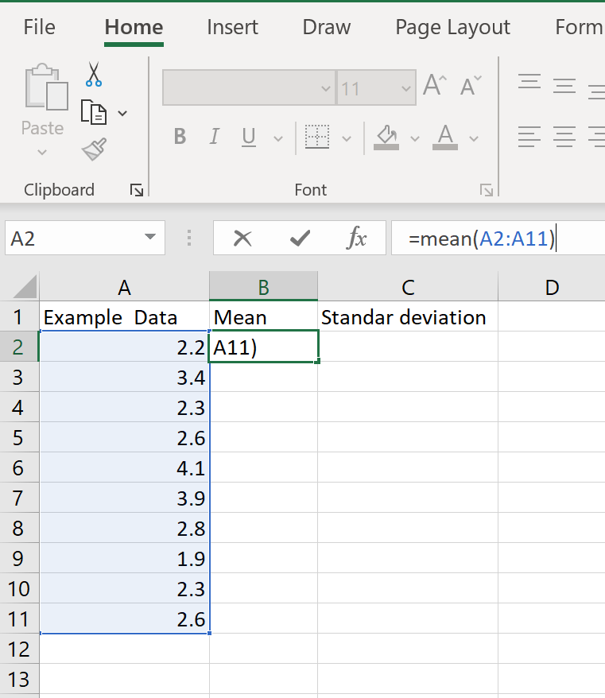

Function Input

Data Set

**Task:**

1. For the two data sets below, determine the mean and standard deviation for both sets. Use the Excel commands *mean()*, and *std()*. Note, you can define a “new variable” in MATLAB and simply copy and paste the data into *variables worksheet*. Remember to rename the variables something appropriate e.g. *DS1* & *DS2*. (15pts)

|  |  |
| --- | --- |
| Data Set 1 | Data Set 2 |
| 0.1 | 1233 |
| 0.23 | 1189 |
| 0.3 | 1309 |
| 0.41 | 1198 |
| 0.12 | 1240 |
| 0.22 | 1177 |
| 0.31 | 1322 |
| 0.11 | 1276 |
| 0.24 | 1212 |
| 0.09 | 1194 |

Section #2: **Uncertainty**

The uncertainty in a measurement is limited by the precision and accuracy of the measuring instrument. It represents the range of possible values within which the true value of the measurement lies. Some devices can make measurements with better resolution than others. For instance, a caliper can measure lengths accurately up to a hundredth of a millimeter while a meter stick can only measure up to a half of a millimeter. How can we determine the uncertainty of a device? Rule of thumbs: (a) Experimental uncertainties should be rounded to one significant figure, and (b) Always round the experimental measurement or result to the same decimal place as the uncertainty.

**Analog Devices**: The uncertainty from devices whose measurements are read from a physical scale (such as a meter stick) is determined by taking half of the smallest “tick”.

**Digital Devices**: The uncertainty from devices whose measurements are read from a digital display (such as digital multimeters) is half of the lowest digit.

**Task:**

1. Determine the uncertainty for each of the measurements made with both the analog and digital devices *e.g.* in the measured value of 52 cm ±1 cm the uncertainty is the ±1 cm portion. (15pts)

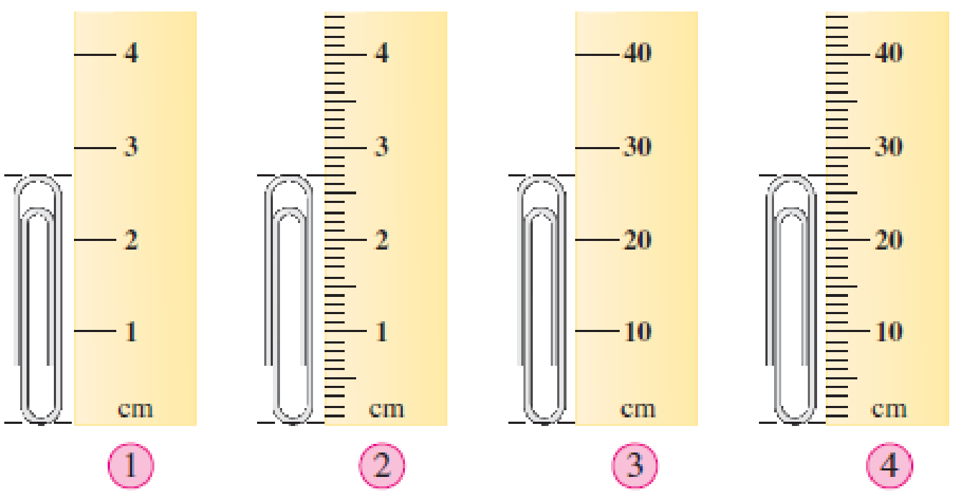

*This figure depicts a paper clip being measured by 4 different rulers, each with a different sized scale.*

1.) 3cm ± 0.5 cm 2.)2.7cm ± 0.5mm 3.)30cm ± 5cm 4.)27cm ± 0.5cm

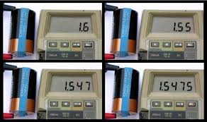



**1**

**2**

**3**

**4**

*This figure depicts a digital voltmeter measuring the voltage of a battery where in each insistence the precision of reading is increased.*

1.) 1.6V ± 3e-1 V 2.) 1.55V ± 2.5e-2 V 3.) 1.547V ± 3.5e-3 V 4.) 1.5475 ± 2.5e-4 V

Section #5: **Error Propagation (Uncertainty Propagation)**

There are instances where the instrument cannot explicitly provide the desired experimental value. Therefore, the final result is determined through either computation and/or a combination of other measurements. Of course, those other values might have an associated uncertainty and therefore the uncertainties propagate to a final value. This final uncertainty depends on the individual uncertainties of the measurements and the mathematical operations used to calculate the final result. The table below shows measurements **A** and **B,** their uncertainties **A** and **B,** and how to determine the uncertainty of a calculated value **Z.**

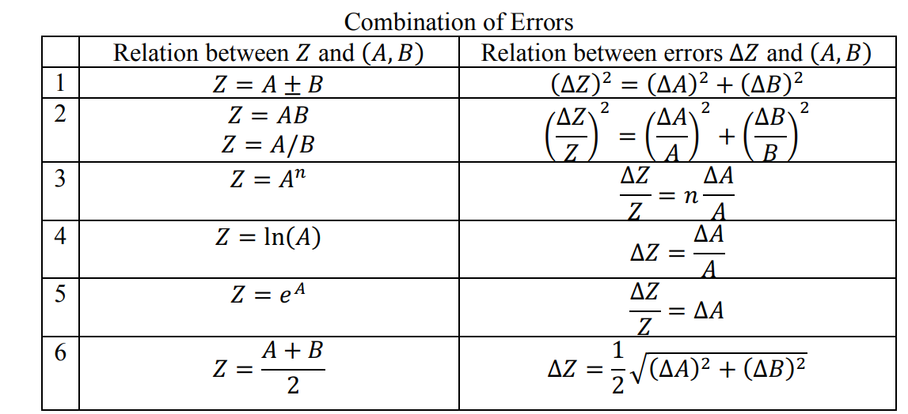

**Task:**

Consider an experiment where we drop a ball from rest from the top of a kitchen table to determine the acceleration due to gravity (*g)*. We will measure the time it takes for the ball to drop to the floor with a stopwatch which can measure up to a tenth of a second. The height of the kitchen table is measured with a meter stick whose smallest tick spacing is a millimeter and is measured to be 0.954 m. The measured time is 0.5 s. What is the uncertainty in *g.*

*Hint

*g = 2 * (yf – yi)/ t2*

*g = 7.632m/s2*

(Δg / g)2 = (2*(0.0005)/(2*(0.954)))2 / ( (2*t2*(0.05/t)) /(t2))2

(Δg / g)2 = (0.0005/0.954)2 / ( (0.52*0.2) /(0.52))2

(Δg / g)2 = (0.0005/0.954)2 / (0.2)2 = 2.75e-7 / 0.04 = 6.87e-6

Δg = 7.632 * sqrt(6.87e-6) = 7.632 * 0.002620545 = 0.02 m/s2

Δg= 0.02 m/s2